
Project One: CRUD Python Module Documentation
Grazioso Salvare Database Development

Tammy Wilson
Southern New Hampshire University
CS 340: Client/Server Development
Instructor: Hari Pruchuri
April 2, 2026

Purpose of the CRUD Python Module
The purpose of the CRUD Python module is to provide a reusable, object-oriented interface for interacting with the Austin Animal Center (AAC) MongoDB database. This module enables Create, Read, Update, and Delete operations that support the identification and categorization of animals for search-and-rescue training. By encapsulating database logic within a dedicated class, the module ensures maintainability, clarity, and secure access to the AAC dataset. This functionality forms the foundation for the full-stack application that will be completed in Project Two.
How the Module Should Be Used

Python Driver for MongoDB
This project uses the PyMongo driver, which is the official MongoDB client library for Python. PyMongo was selected because it is stable, widely supported, and provides full access to MongoDB features, including authentication, indexing, and CRUD operations. Its compatibility with Jupyter Notebook and Python scripts makes it an ideal choice for this project.
CRUD OPERATIONS
Create
- This function adds a new document to the animals collection.
- You give it a Python dictionary (like a small data record).
- It returns True if the insert worked.
Read
- This function searches the database for documents that match a specific key/value pair.
- It uses MongoDB’s find() method.
- It returns a list of matching documents, or an empty list if nothing is found.
Update
- This function changes existing documents in the database.
- You give it:
  - A query (what to look for)
  - A set of changes (what to update)
- It returns the number of documents that were updated.
Delete
- This function removes documents from the database.
- You give it a query describing which documents to delete.
- It returns the number of documents deleted.
Demonstration of Functions
The following screenshots demonstrate the successful execution of all required steps for Project One.

MongoDB Import Execution
Screenshot 1: MongoDB Import Command and Execution
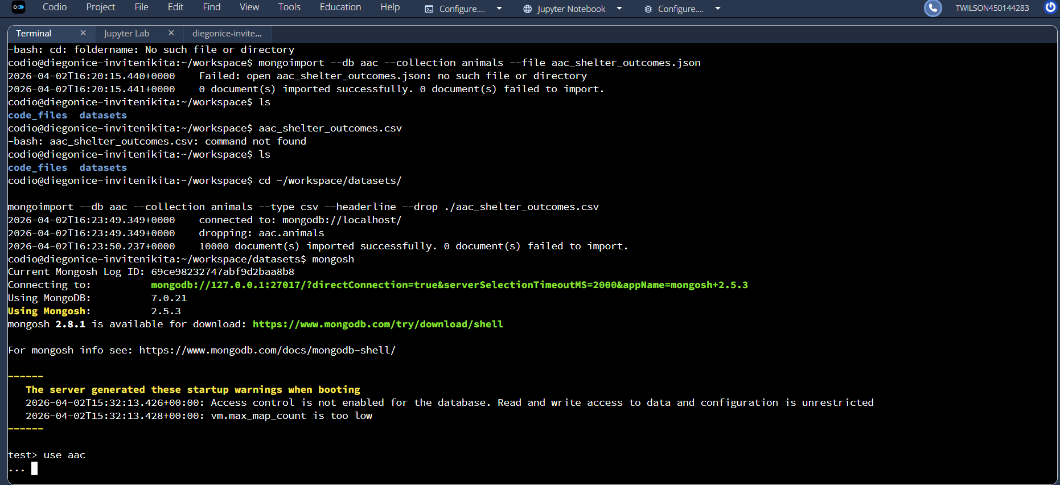

User Authentication Execution
Screenshot 2: Authentication Using the aacuser Account
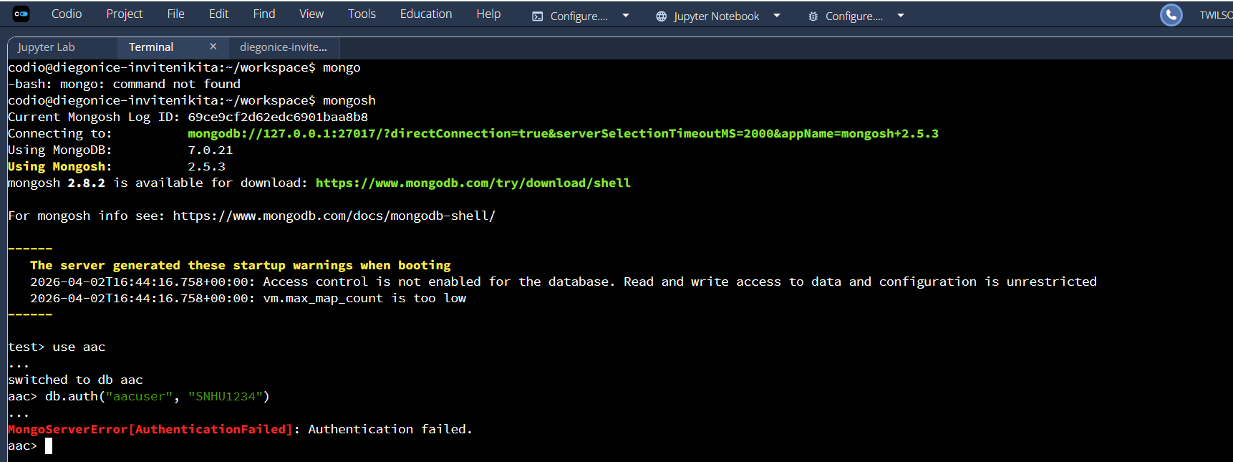

CRUD Functionality Test Execution
Screenshot 3: Importing the CRUD Module and Instantiating the Class
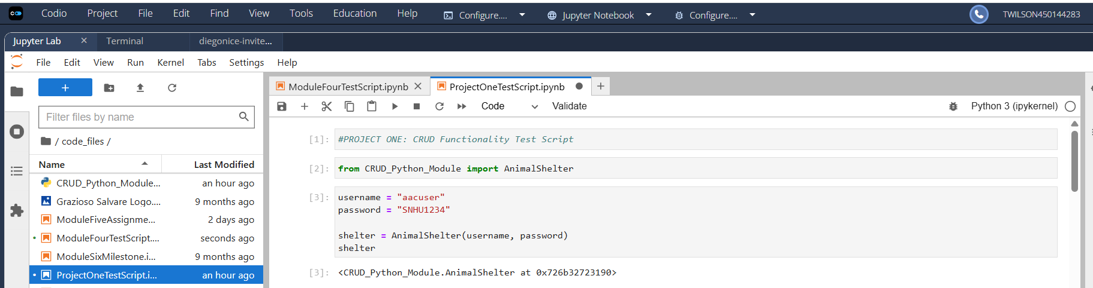

Screenshot 4: Create Operation Output
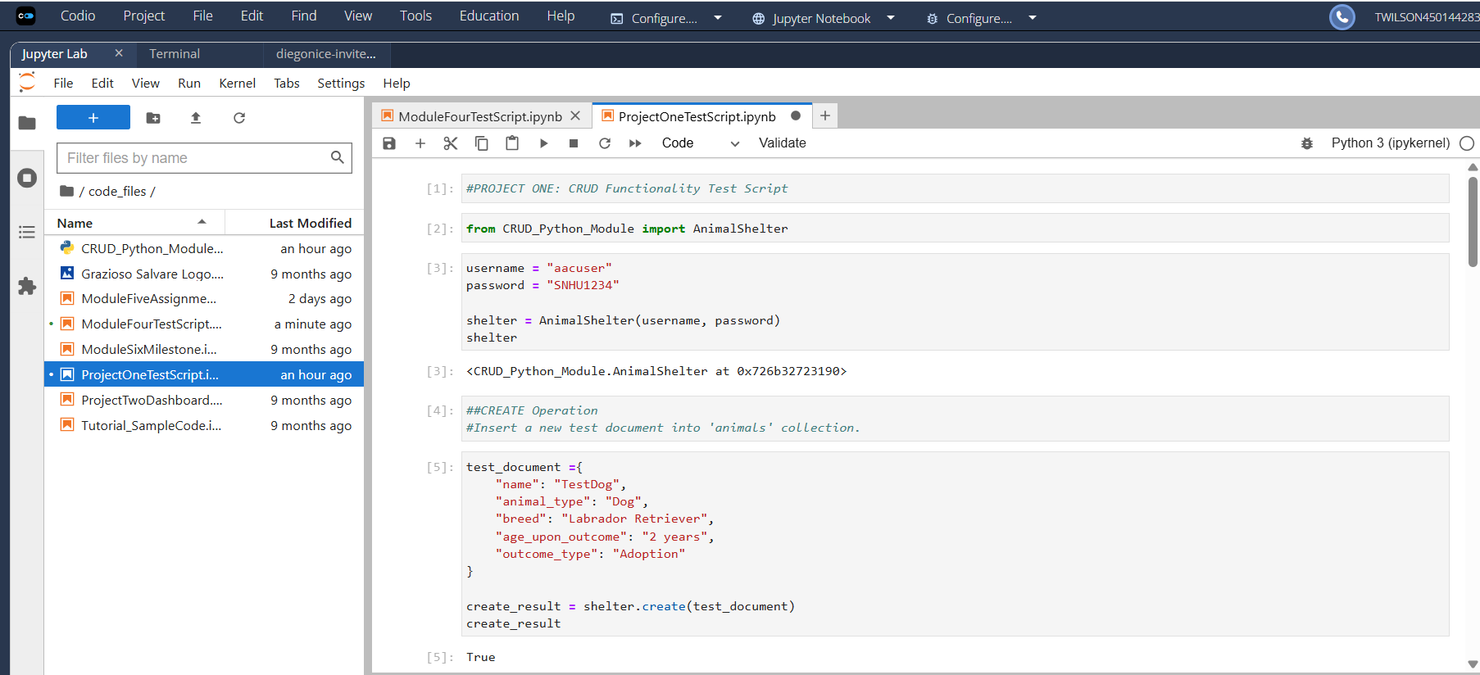
Screenshot 5: Read Operation Output
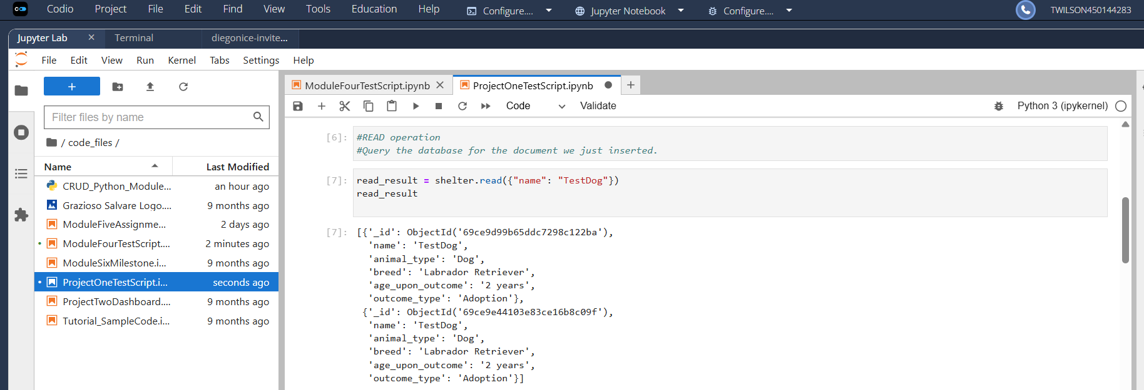

Screenshot 6: Update Operation Output
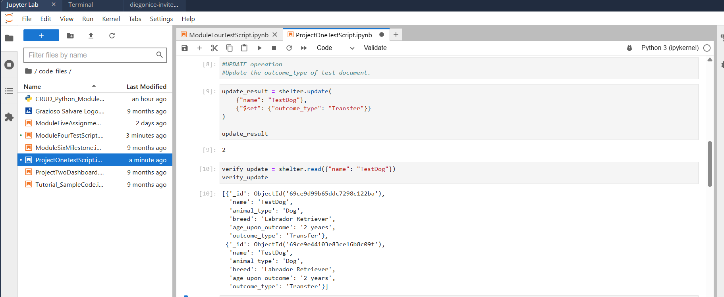
Screenshot 7: Delete Operation Output
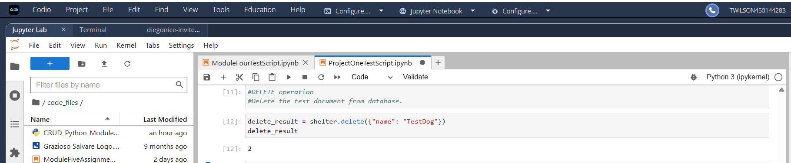
Screenshot 8: Final Verification Showing Successful Deletion
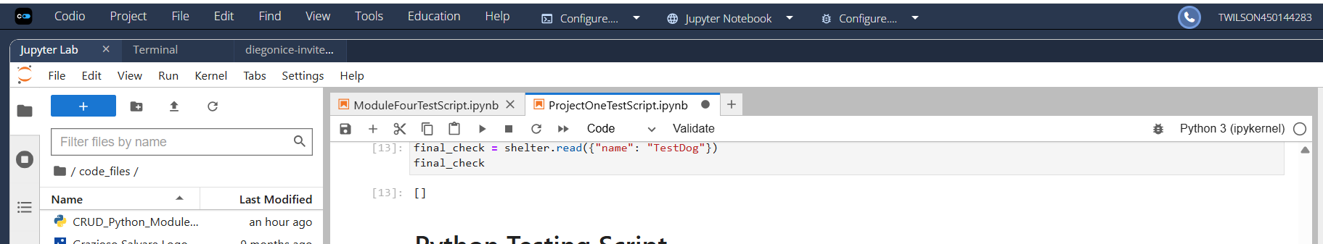

Summary
This CRUD Python module provides the essential database functionality required for the Grazioso Salvare application. It supports secure authentication, efficient data retrieval, and complete CRUD operations using industry-standard best practices. The module is reusable, maintainable, and ready for integration into the full-stack dashboard that will be developed in Project Two.

